**Github Migration Procedures (Remote Machine)**

**For older windows, must have:**

* Visual C++ Redistributable Packages
  + [**https://www.microsoft.com/en-au/download/details.aspx?id=48145**](https://www.microsoft.com/en-au/download/details.aspx?id=48145&fbclid=IwZXh0bgNhZW0CMTAAAR23fy31USRD0v4FMxVD3lXvmSs3j9lyZw5NzymJ7XLqS-Q30JWcrhZRIqc_aem_wmflCYCR26xuecLbRWtLSQ)
* Powershell for windows 7
  + [**https://github.com/PowerShell/PowerShell/tree/0883438e5524efd8558a29cdbbd2bd63bebe9484?tab=readme-ov-file**](https://github.com/PowerShell/PowerShell/tree/0883438e5524efd8558a29cdbbd2bd63bebe9484?tab=readme-ov-file&fbclid=IwZXh0bgNhZW0CMTAAAR1xJR1R9gN2x1vtSGX3kVhBw9hyPyM2q5eOPeetJ_GYguyp4UswOw2Y-M8_aem_mbj07mRNJztMW6h6iCWWdw)
* Git (old version)
  + https://github.com/git-for-windows/git/releases/download/v2.16.2.windows.1/Git-2.16.2-64-bit.exe

**Clone a repository**

* Run commands
  + git clone (repository url)
  + Example: git clone <https://github.com/jezraelsalinokplus/VergolaPerth.git>

**Setup a self-hosted runner to the repository**

**Prerequisites**

* A Windows machine
* Administrator access
* [GitHub account](https://github.com/)
* Installed [PowerShell](https://docs.microsoft.com/en-us/powershell/)

**Steps to Set Up a Self-Hosted Runner**

* Create a Runner on GitHub
  + Navigate to your GitHub repository.
  + Go to Settings > Actions > Runners.
  + Click New self-hosted runner.
  + Select Windows and follow the instructions to download the runner package.
* Install and Configure the Runner
  + Open PowerShell and navigate to the downloaded directory.
  + Extract the runner package:
  + ./config.cmd --url https://github.com/your-repository --token YOUR_TOKEN
  + When setting up runner make sure to name the runner with the repository name
  + Leave it to default (Press Enter)
  + 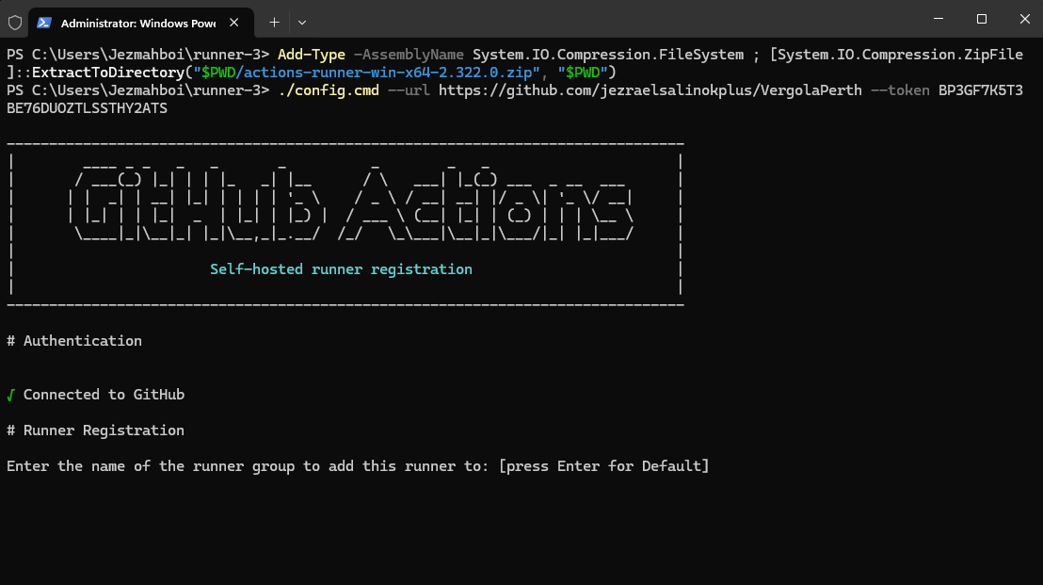
  + Name the runner to “runner-repository name”
  + Example: runner-vergolaperth
  + 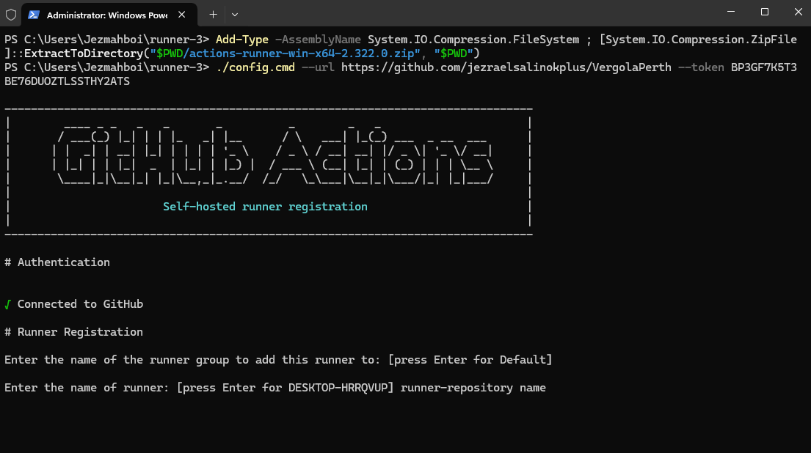
  + And the label must be the same as the runner name
  + 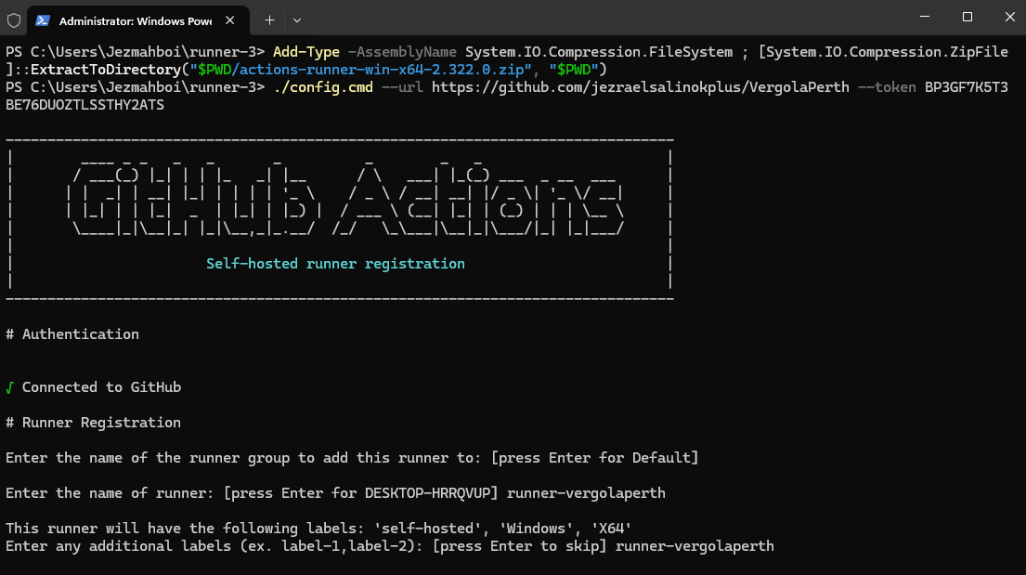
  + In here just press Enter
  + 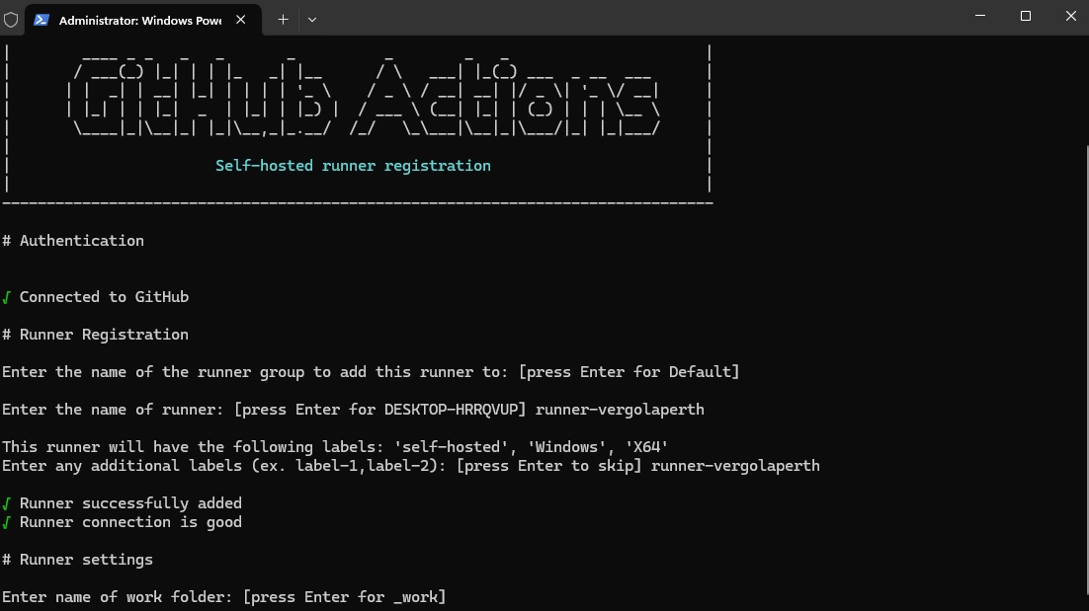
  + Input “y” to run it as service and press Enter
  + 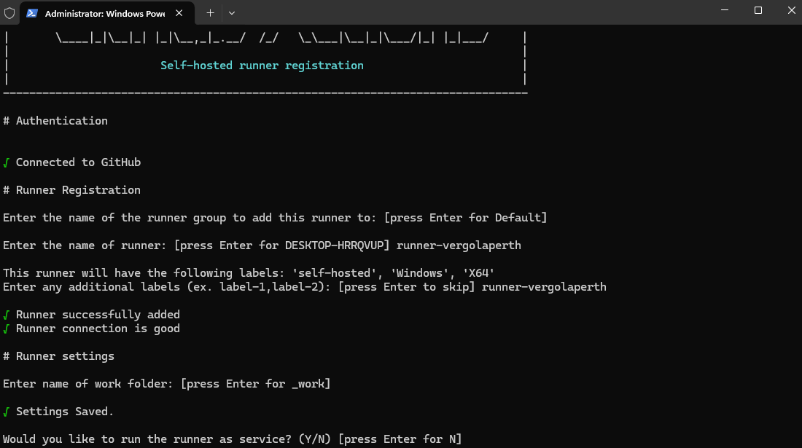
  + Enter you User’s Name
  + 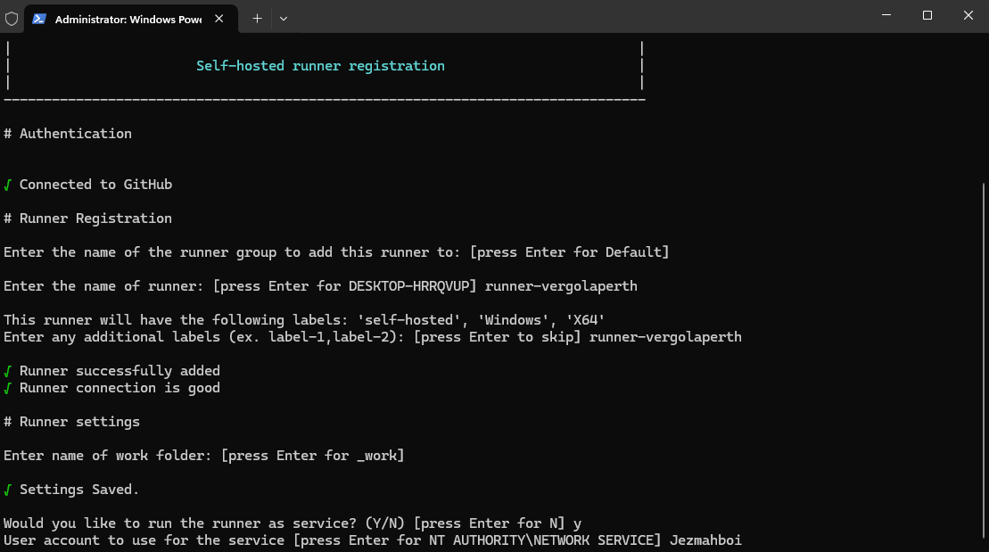
  + In my case its Jezmahboi
  + And type you computer password (if needed)
* Run the Self-Hosted Runner Manually
  + Start the runner:
  + ./run.cmd
  + Keep the terminal open while the runner is active.
* (Optional) Install as a Service Manually
  + To run the runner in the background as a Windows service:
  + ./svc install
  + ./svc start